INSTRUCTIONS FOR ANALOG WATCH WITH SLIDE BATTERY

COMPARTMENT
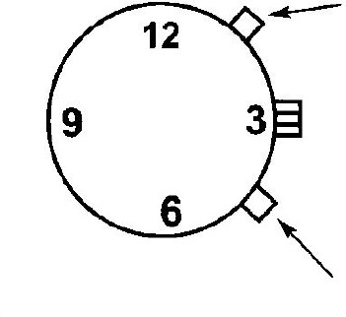
S1

S2
Your watch will arrive in SLEEP mode to preserve battery life. To turn sleep mode off and start using your watch, press and hold S1 for 3 seconds.

HOW TO ANNOUNCE TIME AND DATE
In standby mode,
- Press S1 to announce time. After time announced press S1 again or press twice S1 to report date

ANALOG FACE SETTING
The analog face is set separately from the talking time. To set the face time, pull out the crown and twist to reach the desired time.

FUNCTION SETTINGS
- Press S2 for 3 seconds to enter menu. You will hear the first setting option. You can move through the different options by repeatedly pressing S2. Setting options, in order, are:
Hourly chime on /off → Alarm on/off → Alarm hour setting → Alarm minute setting → Alarm sound setting (choice of 3) → Year setting → Month setting → Date setting →Hour setting → Minutes setting → Standby mode
- Press S1 to change the setting for that particular function. Press S1 as many times as needed to reach the desired value.

HOW TO ENTER SLEEP MODE
- To wake up the watch from sleep mode: Press S1 button and hold for 3 seconds
- Put the watch into sleep mode: In standby mode, press S1 key button and hold for 8 seconds.

CHECK ALARM STATUS – ALARM ON / OFF
In standby mode, press S2 to check whether the alarm is on or off.

BATTERY REPLACEMENT:
There is a small hole under the crown of the watch. Use a thin metal rod (such as a paper clip) to enter the small hole and push out the metal battery pocket. After removing the battery compartment, you can replace the CR2016 lithium battery, and then carefully slide the battery holder back into the watch.

