Instructions For Atomic Talking Clock

- Function Brief
- Radio-controlled：Receives signals automatically or manually
- Talking function (male/female voices interconvertible)
- 5 sets of alarms (Three times of snoozes for each alarm)
- 5 alarm tones selectable
- Hourly Chime (From 7 a.m. to 8 p.m.)
- low battery voice reminder
- 5 seconds of LED backlit.
- Adjustable volume (on a scale of 0 to 5)
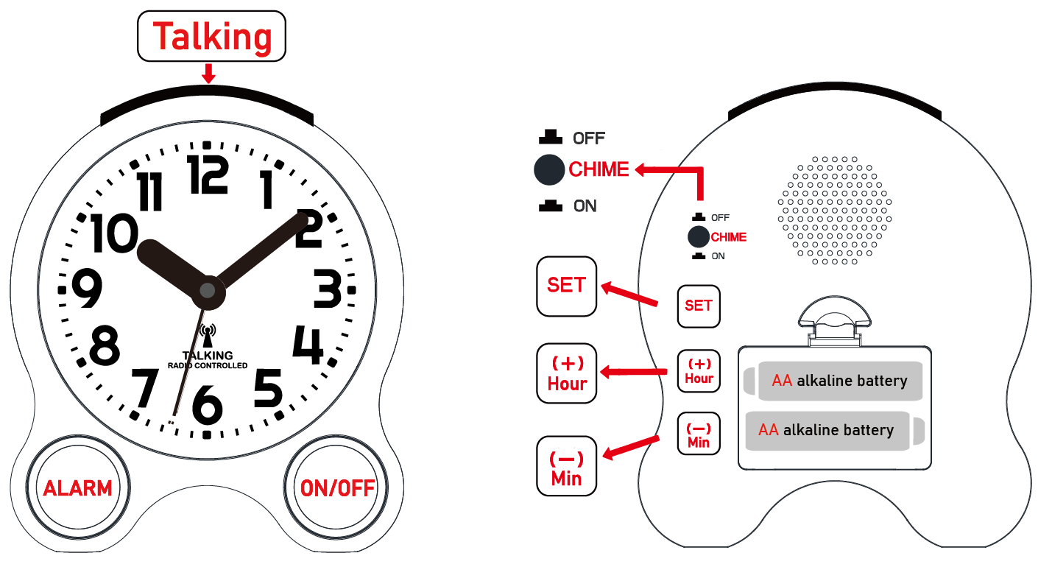
- Power saving: The second hand will stop moving automatically from midnight to 6a.m.

- Button functions

- TALKING button: Speaks time, date, and reception status
--The first push: “The time is 10:09 a.m.”
--The second push: “Today is Friday October 21st.”
--The third push: “Time updated”or“Time not updated”

- ALARM button- Announces alarm time and on/off status
--The first push: “Alarm 1 is 6 o’clock a.m. , alarm is ON”
--The second push: “Alarm 2 is 6 o’clock a.m. , alarm is OFF”
…….Total 5 sets of alarms

- ON/OFF button- Ringing tone selection
-- Press it repeatedly to select the ringtone you’d like(total 5 options).

- CHIME button- Turn on/off the hourly chime
--Press the CHIME button to turn ON/OFF the hourly chime

- SET button- LED backlight or enter setting modes
--Press the SET button briefly to light up the LCD backlit for 5 seconds
--Press and hold the button for about 1 second enter settings

- Hour（+）and Min(-) buttons- To adjust the volume
--Press the Hour(+) button repeatedly to increase the volume
--Press the Min(+) button repeatedly to reduce the volume

- Battery installation

- The clock requires 2 AA alkaline batteries. Please install the batteries properly in the battery slot (on the back of the clock) and don’t use the carbon battery, it has low power storage.
- Power-on
- After batteries were installed, the clock hands will be pointing to 12 o’clock and starts to searching for signal automatically.( It takes roughly 5 minutes for the signal reception).
- After the signal is received successfully, the hands will be spinning fast to the correct time. Please follow the “Time zone setting” section to set your time zone accordingly.
- If you live far from the USA(WWVB) tower or if there has strong interference around you. The clock may unable to receive the signal during the day time.
- Therefore, the clock will be just start working from 12 o’clock, You could follow the “Manual signal reception“ part to try again (place the clock near the window), or manually set the time and time zone first, then wait until midnight, the clock will start the reception automatically every night at 3 a.m.
(be sure that the correct time and time zone has been set or the clock will not be able to pick the Local signal at 3 a.m. )
- Manual signal reception
- Press and hold Hour(+) and Min(-) button simultaneously about 1 second. The second hand will be stop moving after “DI “sound. It means the clock now is receiving signals.
- In the meanwhile, you could press and hold Hour(+) and Min(-) simultaneously about 1 second to stop the reception.
- Switching between male and female voices

- Press and hold the TALKING button about 3 seconds to switch between male and female voice.
- Volume adjustment(on a scale of 0-5)
- In the normal running mode
--Press the Hour(+) button repeatedly to increase the volume
--Press the Min(+) button repeatedly to reduce the volume

- Time zone setting-Four time zones
- You need to set your time zone every time you changed the battery :
- Press and hold SET button; the clock says: “Time zone setting”
- Press Hour(+) or MIN(-) to switching between the four time zones cyclically
- Press TALKING button to confirm.
- Manually settings for Time & Date
- If the signal reception failed after power-on you could set the correct local time manually:
- In the normal running mode, press and hold SET button, the clock says: “Time zone setting…...”
- Press SET button again , the clock says: Set time
- Press Hour(+) button to set hour, press Min(-) to set minute .
- Press SET button enters year setting.
- Press Hour(+)or Min(-) button to set year, (Hour(+) is to increasing the numbers, and Min(-) is to reducing ).
- Press SET button enters month setting.
- Press Hour(+) or Min(-) button to set month
- Press SET button enters day setting.
- Press Hour(+) or Min(-) button to day ,
- After all the setting has done, press the TALKING button(on the top) to confirm.
Note:
- If there is no subsequent operation within 10 seconds, it will confirm the setting and exit automatically.
- You could press the TALKING button to confirm and end the setting at any moment when you finished all the settings you wanted.
- After confirmation, the hands will be moving fast to match the time you’ve just set. (All the buttons will not work during this time)
- SET ALARM
- Alarm time checking:
- In the normal running mode. Press ALARM button circularly to switch ALARMs from 1-5 in sequence.
- Every time you press the ALARM button, it will speak the alarm time and state accordingly, for example: “ALARM 1 is 6:00 o’clock a.m. alarm is ON”.
- ALARM ON/OFF
- You could press ON/OFF button to set toggles for each alarm when it announces the alarm time.
- For example: press ALARM button once ,it says : “ALARM 1 is 6:00 o’clock a.m. Alarm is ON”, then press ON/OFF button to turn ON or OFF the alarm, and press ALARM button to confirm.
- Press ALARM button twice ,it says : “ALARM 2 is 6:00 o’clock a.m., alarm is ON”, then press ON/OFF button to turn ON or OFF the alarm, and press ALARM button to confirm.
- After confirmation, the clock will announce the alarm time and on/off state.
- When the alarm tone starts to ring, press TALKING button to stop it or press ALARM button to turn on the snooze function, that means the alarm tone will be ring up again after 5 minutes (total 3 times of snooze).
- ALARM TIME SETTING:
- In the normal running mode. Press ALARM button circularly to choose which alarm you want to set.
- Press ON/OFF button to set the alarm on or off
- Press Hour(+) to set hour, Min(-) to set minute
- Press ALARM(or TALKING) button to confirm.
- After confirmation, the clock will announce the alarm time and on/off state.
- Alarm tone selection
- In the normal running mode, press ON/OFF button repeatedly to switch the ringtone in sequence (total 5 ringtones are available).

- Hourly Chime ON/OFF
- In the normal running mode, press CHIME button(on the back) to switch ON/OFF. The clock will speak the status accordingly.
- When the hourly chime is ON. it will be working from 7 a.m. to 8p.m only.
- LED backlit: It will light up 5 seconds every time you press SET button briefly.

